HELLENIC MINISTRY OF HEALTH
EVAGGELISMOS GENERAL HOSPITAL

DEPARTMENT OF ENDOCRINOLOGY
RARE ENDOCRINE DISEASES CENTER

PITUITARY GLAND
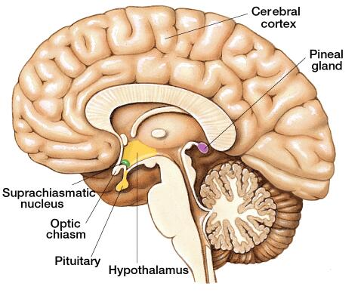
The pituitary gland has the size of a pea, and is found at the base of the brain, just behind the nose. It produces several hormones; which regulate the peripheral endocrine glands or organs of the bodyn. Pituitary hormones affect growth (growth hormone-GH), metabolism (thyroid stimulating hormone -TSH and adrenocorticotropin-ACTH), bone health and the production of sex hormones (gonadotrophins FSH and LH).

Pituitary Adenomas

Pituitary adenomas are small, benign tumours that can`affect the normal function of the pituitary gland.
There are two types of pituitary tumors: secretory (which produce hormones) and non-secretory (which no hormonal production). The symptoms of the pituitary adenomas can be caused by the tumour itself especially when it is big and extends to the neighbouring tissues (optic nerve..) or by the hormonal changes (the production of either too much or too little hormone). As a result, ACTH-producing adenomas can cause Cushing’s disease. Growth hormone-producing tumors can cause acromegaly. Prolactin-producing tumors can cause irregular or absent menstrual periods in women. In men, these tumors can cause sexual dysfunction and infertility.
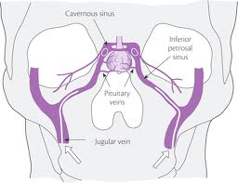
-How are the pituitary adenomas diagnosed?
Your doctor will evaluate your symptoms and will refer you to measure hormone levels. You may also have to undergo an MRI (magnetic resonance imaging) scan of your pituitary gland as well as an eye test (visual field testing). In case that a pituitary adenoma is found, it is essential for the doctor to specify the type of the adenoma and plan ahead your treatment.
-How are the pituitary adenomas treated?
Treatment depends on the type of tumour, how large it is, what symptoms it is causing, and your age and overall health. Your doctor will try to find the best treatment option for you. Some types of tumours can be treated with medication alone or can be observed over time for any changes. Other types of tumours require surgery, or a combination of treatments, including radiation therapy.

Hypopituitarism
Hypopituitarism is a rare condition in which some or all the hormones of the pituitary gland are not secreted correctly. As a result, important glands (thyroid gland, adrenal gland, testicles, ovaries) don't get the hormones they need from your pituitary gland and cannot function properly. It usually takes several months or even several years for the symptoms of hypopituitarism to evolve.
What can cause hypopituitarism;
- Tumors in or near the pituitary gland (which are usually benign)
- Radiation treatment for a tumour, which can destroy pituitary gland tissue
- Brain surgery
- Severe bleeding in the brain or severe blood loss during childbirth
- Certain conditions present at birth (congenital hypopituitarism)
Sometimes the cause remains unknown.
Symptoms can include one or more of the following:

- Stomach pain, decreased appetite, nausea and vomiting, and constipation
- Excessive thirst and urination
- Fatigue and/or weakness
- Anemia
- Headache and dizziness
- Sensitivity to cold
- Stiffness in the joints
- In women: irregular or no menstrual periods, infertility
- In men: loss of hair (on the face, or in the armpits or pubic area), decreased sex drive, infertility

How is hypopituitarism diagnosed?
Your doctor will check your hormone levels with blood tests. You may have other tests, such as an MRI of your pituitary gland, to help find the cause of your hypopituitarism.

What is the treatment for hypopituitarism?
Treatment usually includes taking the hormones you're missing. Your doctor also will teach you how to take extra cortisone when you are sick or under stress.

You will need to get regular check-ups. It's wise to have a medical identification such a ‘stress card’, which provides information about your condition in case of an emergency.

